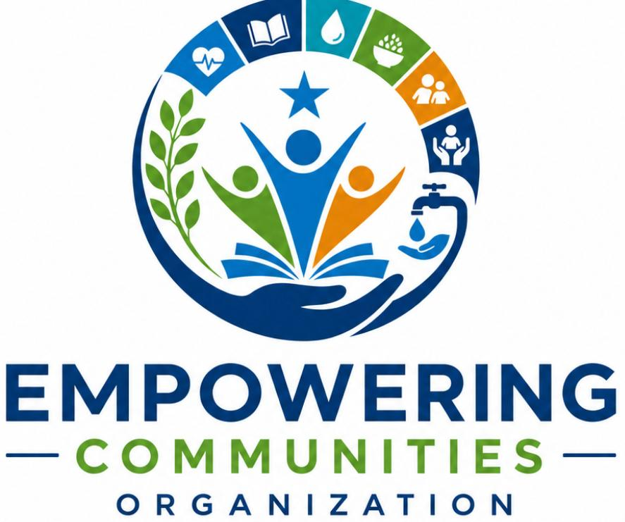
FIELD ACTIVITY REPORT
Community Mobilization and Engagement Activity
Hygiene Promotion and Protection Sensitization and Awareness
Report Compiled By: Mohamed Ismail
Contact: +252612598185
ACTIVITY DETAILS
Activity Name | Community Mobilization and Engagement
Location | Dalxis IDP Camp Community Center, Kismayo, Jubaland, Somalia
Date | 28th July 2026
Time | 3:00 PM – 4:00 PM
Implementing Organization | Empowering Communities Organization (ECO)
Address | 1400 Farjana Road, Kismayo, Somalia

EXECUTIVE SUMMARY
EXECUTIVE SUMMARY
On 28th July 2026, Empowering Communities Organization conducted a second community mobilization and engagement activity at the Beder IDP camp community center in Kismayo. The activity focused on hygiene promotion and protection sensitization and awareness, reaching a total of 56 participants comprising 41 women, 12 girls, and 3 men. The Beder camp is predominantly inhabited by the Somali Bantu community, a minority group that has historically faced marginalization and discrimination.
The activity was implemented through ECO's own initiative without formal funding. During the session, the organization utilized the Somalia Common Key Messages for Flooding developed by the Community Engagement and Accountability Task Force in coordination with SoDMA and various humanitarian clusters. These messages were disseminated in Maay and Maxaatiri to ensure full accessibility for the Somali Bantu community, many of whom primarily speak Maay dialect.
The session provided a platform for the community to discuss their protection concerns and the specific vulnerabilities facing the Somali Bantu population in the displacement context.
BACKGROUND AND CONTEXT
Situation of Somali Bantu IDPs in Kismayo
The Somali Bantu community represents one of the most marginalized minority groups in Somalia. Historically subjected to discrimination and exclusion, Somali Bantus have faced particular vulnerabilities in displacement contexts. Many Somali Bantu families in Kismayo's IDP camps originate from the Juba Valley regions and other areas of southern Somalia where they traditionally engaged in farming and agricultural livelihoods.
The Beder IDP camp is one of several settlements in the Kismayo area predominantly inhabited by Somali Bantu families. These communities face compounded vulnerabilities due to their minority status, historical marginalization, and limited access to basic services and livelihood opportunities. Despite the presence of durable solutions programs in the region, including the relocation of 600 households to Kismayo North, significant gaps remain in reaching the most vulnerable populations.
Humanitarian Context
Somalia continues to face one of the world's most complex humanitarian crises, with IDPs remaining among the most food-insecure populations in the country. Most IDP settlements are classified in Crisis (IPC Phase 3), with some areas facing Emergency (IPC Phase 4) conditions due to conflict and drought that continue to drive displacement. Limited income-earning opportunities, few assets, and high food prices continue to drive acute food insecurity among IDPs.
The humanitarian situation is compounded by the fact that food assistance is planned and funded to reach only 5-10 percent of the population in need, with reduced rations due to funding shortfalls and restricted access in certain operational areas. This context underscores the importance of community-led initiatives like the activity conducted by ECO.
Flood Preparedness and Response
March 2026 saw the development of the Somalia Common Key Messages for Flooding through coordination between SoDMA, CEA TF partners, and various ICCG clusters and working groups. These messages were designed to be embedded across all communication and community engagement activities throughout the rainy and flooding season, providing guidance for all stages of flooding including preparedness, caution during flooding, and early and long-term recovery.
The dissemination of these messages in the Beder IDP camp was particularly timely given the recent flash floods affecting the Dalxis area and the ongoing risks faced by IDP communities as the rainy season continues.
ACTIVITY OBJECTIVES
The primary objectives of the community mobilization and engagement activity were:
- To raise awareness on hygiene promotion practices to prevent disease outbreaks in the IDP camp setting
- To sensitize the community on protection issues, including child protection and human trafficking prevention
- To engage with the Somali Bantu community to understand their specific needs and concerns
- To disseminate the Somalia Common Key Messages for Flooding in accessible languages (Maay, Maxaatiri, English)
- To provide information on available complaints and feedback mechanisms
PARTICIPANT DEMOGRAPHICS
The activity reached a total of 56 participants, with the following breakdown:
Category | Number of Participants
Women | 41
Girls | 12
Men | 3
Total | 56

The high representation of women (73.2% of total participants) reflects the demographic composition of IDP camps where women and children constitute the majority of the displaced population. The limited male participation (3 men) is consistent with patterns observed in IDP settings where men are often engaged in daily labor activities outside the camp. The Beder camp's Somali Bantu population represents a minority group with distinct cultural and linguistic characteristics that informed the approach to the activity.
ACTIVITY IMPLEMENTATION
Methodology
The activity was conducted through a combination of formal presentations, group discussions, and open dialogue sessions. The Community Center at Beder IDP camp served as the venue, providing a familiar and accessible space for community members to gather. The session was facilitated by ECO staff who utilized participatory approaches to ensure all voices were heard and valued.
Given the linguistic diversity of the Somali Bantu community, facilitators delivered the session in both Maay and Maxaatiri dialects to ensure full accessibility. Written materials and key messages were also available in English for those who could read. The use of multiple languages reflected ECO's commitment to inclusive programming that reaches all community members regardless of their linguistic background.
Hygiene Promotion Component
The hygiene promotion session covered the following key areas:
- Importance of handwashing with soap at critical times
- Safe water handling and storage practices
- Proper sanitation and waste disposal
- Prevention of waterborne diseases
- Menstrual hygiene management for women and girls
The facilitators emphasized the link between poor hygiene practices and disease outbreaks, which are of particular concern in crowded IDP settings where access to clean water and sanitation facilities is limited. The session also addressed the specific health risks associated with flooding, including waterborne diseases and mosquito-borne illnesses.
Flood Messaging Component
A significant portion of the session was dedicated to disseminating the Somalia Common Key Messages for Flooding. These messages were delivered in Maay, Maxaatiri, and English and covered the following areas:
Preparedness before flooding:
- Understanding risks including flooding of communities and agricultural land
- Staying alert and seeking information from radio, humanitarian actors, and community leaders
- Taking action to reduce risks to housing and community assets
- Preparing to move family members, livestock, and belongings if necessary
- Identifying safe high ground for evacuation
- Preparing an evacuation kit with essential supplies
Caution during flooding:
- Staying safe in rushing water
- Protecting children from floodwater dangers
- Staying away from electrical wires and sockets
- Being aware of crocodiles and snakes in flooded areas
- Taking care of health and preventing waterborne diseases
Early recovery after flood water recedes:
- Preventing waterborne disease outbreaks through hygiene practices
- Conserving water during drier periods
- Draining stagnant water and removing dangerous elements
Long term recovery:
- Diverting waterflow for irrigation
- Planting different crops and improving storage
- Making use of increased rains for rangeland recovery
Protection and Accountability Component
- The protection sensitization session addressed the following topics:
- Understanding protection issues in displacement contexts
- Identification of protection risks facing women, children, and vulnerable groups
- Prevention of gender-based violence and available reporting mechanisms
- Raising awareness on child protection
- Understanding the risks of human trafficking and irregular migration
- The session also emphasized key messages on humanitarian accountability, including:
- All humanitarian aid and services are free of charge
- No financial, sexual, or other favors can be requested in exchange for assistance
- Aid diversion is against humanitarian principles and Somali law
- Available complaints and feedback mechanisms for reporting concerns
KEY COMMUNITY CONCERNS AND ISSUES RAISED
The community engagement component of the activity provided a platform for community members to voice their concerns and needs. While the Beder community did not experience the same level of flood damage as the Dalxis camp, they shared the following concerns:
1. Vulnerability of Somali Bantu Population. Community members expressed concerns about the specific vulnerabilities facing the Somali Bantu community in displacement. As a minority group, Somali Bantus have historically faced discrimination and exclusion from services and opportunities. Participants noted that their community often receives less attention from humanitarian actors compared to other groups in the camp.
2. Protection Concerns for Women and Children. Women participants raised particular concerns about protection risks facing women and children in the camp, including the threat of gender-based violence and the challenges of accessing protection services. The limited number of male participants in the session also raised questions about reaching men with protection messages.
3. Limited Access to Information. Community members noted that they often receive limited information about available services and humanitarian assistance. The use of Maay dialect in the session was appreciated, as many Somali Bantu community members are more comfortable communicating in Maay than in Maxaatiri.
4. Human Trafficking Concerns. Similar to concerns raised in the Dalxis camp, participants in Beder expressed concerns about human trafficking affecting youth, with young people being lured with promises of work and prosperity only to be ransomed in Libya.
OBSERVATIONS AND REFLECTIONS
- Language and Accessibility. The use of Maay dialect in the session was particularly important for reaching the Somali Bantu community. Participants expressed appreciation for the effort to communicate in their preferred language, which facilitated engagement and ensured that key messages were understood. This highlights the importance of linguistic accessibility in humanitarian programming.
- Community Engagement. Despite the limited male participation, the high turnout of women demonstrated strong community interest in the topics discussed. Women participants were particularly engaged in discussions about hygiene practices, child protection, and flood preparedness, reflecting their central role in household and community welfare.
- Information Gaps. The session revealed that many community members had not previously received flood preparedness messages in accessible formats. The dissemination of the Somalia Common Key Messages for Flooding in Maay and Maxaatiri helped fill an important information gap for the community.
- Need for Sustained Engagement. The issues raised during the session indicate the need for sustained engagement with the Beder community. One-time awareness activities, while valuable, are insufficient to address the complex challenges facing displaced populations, particularly minority groups like the Somali Bantu community.
CHALLENGES AND CONSTRAINTS
- Resource Limitations. As the activity was implemented through ECO's own initiative without formal funding, resource limitations affected the depth and scope of the engagement. Limited materials, transportation, and personnel constrained the organization's ability to reach all vulnerable groups within the camp.
- Language and Translation. While ECO staff were able to deliver messages in Maay and Maxaatiri, ensuring consistent translation of all technical terms required careful preparation. The complexity of some humanitarian terminology presented challenges for accurate translation.
CONCLUSION
The community mobilization and engagement activity conducted by Empowering Communities Organization at Beder IDP camp on 28th July 2026 successfully reached 56 vulnerable community members with hygiene promotion and protection awareness messaging. The activity utilized the Somalia Common Key Messages for Flooding developed through coordination with SoDMA and various humanitarian actors, disseminating these messages in Maay, Maxaatiri, and English to ensure accessibility for the Somali Bantu community.
The high participation of women in the session (73.2%) demonstrated the community's engagement with the topics discussed, while the limited male participation (3 men) highlights the need for additional efforts to reach men with protection and hygiene messages.
ECO's decision to implement this activity through its own initiative without formal funding demonstrates the organization's commitment to its mission of ensuring Somali communities and children get the support they need. The use of culturally and linguistically appropriate approaches reflects ECO's commitment to inclusive programming that reaches all community members.
ACKNOWLEDGMENTS
Empowering Communities Organization expresses its sincere gratitude to the community of Beder IDP camp for their active participation and willingness to share their experiences and concerns. The organization also acknowledges the support of local authorities and community leaders who facilitated the activity and the dedication of ECO staff and volunteers who contributed to its successful implementation.
CONTACT INFORMATION
Organization | Empowering Communities Organization
Address | 1400 Farjana Road, Kismayo, Somalia
Primary Email | ahmedbule01@gmail.com
Primary Phone | +252 62 8673232
Report Author | Mohamed Ismail, +252 612598185

APPENDIX A: ACRONYMS
Acronym | Full Name
CEA TF | Community Engagement and Accountability Task Force
CCCM | Camp Coordination and Camp Management
CFM | Complaints and Feedback Mechanism
ECO | Empowering Communities Organization
FAO | Food and Agriculture Organization
FEWS NET | Famine Early Warning Systems Network
ICCG | Inter-Cluster Coordination Group
IDP | Internally Displaced Person
IOM | International Organization for Migration
IPC | Integrated Food Security Phase Classification
MHPSS | Mental Health and Psychosocial Support
MoHDMA | Ministry of Humanitarian Affairs and Disaster Management
MPCA | Multi-Purpose Cash Assistance
NRC | Norwegian Refugee Council
PSEA | Protection from Sexual Exploitation and Abuse
ReDSS | Regional Durable Solutions Secretariat
SHCG | Somalia Humanitarian Country Team
SoDMA | Somali Disaster Management Agency
UNHCR | United Nations High Commissioner for Refugees
WASH | Water, Sanitation, and Hygiene

APPENDIX B: REFERENCES
- Community Engagement and Accountability Task Force. (2026). Somalia Common Key Messages for Flooding in Somalia. March 2026.
- FEWS NET. (2026). Somalia Food Security Outlook, October 2025 – May 2026.
- International Organization for Migration. (2026). EU-Funded Project Expanded Access to Shelter, Water and Protection Services for Displaced Communities Across Somalia.
- Radio Kismaayo. (2026). Jubbaland Planning Minister Welcomes High-Level Delegation for Launch of Urban Resilience Project in Kismayo.
- Shabelle Media Network. (2026). Somali police arrest youths accused of planning illegal migration through Kenya.
- SONNA. (2026). Government of Somalia Facilitates the Repatriation of 174 Somali Nationals from Libya.
- Springer. (2026). Climate-induced rural–urban migration in Somalia: security risks, urban fragility, and pathways to resilience.
- UNHCR. (2026). Somalia Protection and Return Monitoring Network Report.
- OCHA. (2026). Somalia Humanitarian Response Plan.
APPENDIX C: GLOSSARY OF TERMS
Term | Definition
Durable Solutions | A comprehensive approach to addressing displacement that includes voluntary return, local integration, or relocation to another part of the country
IDP Camp | A temporary settlement established to accommodate internally displaced persons
Maay | A dialect of the Somali language primarily spoken by the Somali Bantu and other communities in southern Somalia
Maxaatiri | The standardized dialect of the Somali language used in official communication and media
Somali Bantu | A minority ethnic group in Somalia, historically marginalized, with distinct cultural and linguistic characteristics

APPENDIX C: Activity Photos
