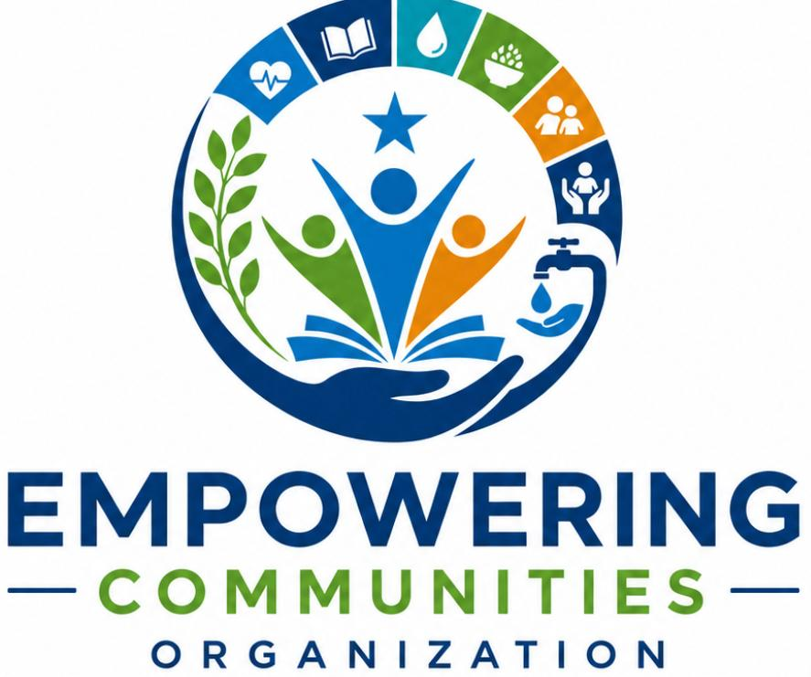
FIELD ACTIVITY REPORT
Community Mobilization and Engagement Activity
Hygiene Promotion and Protection Sensitization and Awareness
Report Compiled By: Mohamed Ismail
Contact: +252612598185

ACTIVITY DETAILS
Activity Name | Community Mobilization and Engagement
Location | Dalxis IDP Camp Community Center, Kismayo, Jubaland, Somalia
Date | 17th July 2026
Time | 9:00 AM – 11:00 AM
Implementing Organization | Empowering Communities Organization (ECO)
Address | 1400 Farjana Road, Kismayo, Somalia

EXECUTIVE SUMMARY
On 17th July 2026, Empowering Communities Organization conducted a community mobilization and engagement activity at the Dalxis IDP camp community center in Kismayo. The activity focused on hygiene promotion and protection sensitization and awareness, reaching a total of 76 participants comprising 49 women, 12 girls, 8 elders, and 7 boys. The session was implemented through ECO's own initiative without formal funding, demonstrating the organization's commitment to serving vulnerable communities despite resource constraints.
The activity provided a critical platform for the Dalxis IDP community to voice their pressing concerns and needs. The community highlighted severe shelter challenges following recent flash floods that devastated Camp Halane within the Dalxis settlement, the persistent threat of human trafficking affecting youth, and the prohibitive cost of healthcare at Kismayo General Hospital. These issues reflect the broader humanitarian crisis facing internally displaced populations in Jubaland, where over 3.9 million Somalis remain internally displaced due to conflict, climate shocks, and environmental degradation across somalia.
BACKGROUND AND CONTEXT
Situation of IDPs in Kismayo and Jubaland
Kismayo, the administrative capital of Jubaland, hosts a significant population of internally displaced persons who have fled conflict, drought, and other hardships from various parts of southern and central Somalia. The displacement situation in Jubaland remains among the most complex in the country, with climate-induced rural-urban migration increasingly reshaping the region's development and security landscape. Research indicates that IDPs in Kismayo face high perceptions of urban fragility and multidimensional security risks, with many having lived in urban settlements for over 6 months, suggesting increasingly permanent displacement.
The Dalxis IDP camp represents one of several settlements accommodating displaced families in the Kismayo area. According to the National Durable Solutions Strategy, comprehensive collaboration between development, humanitarian, and peace-building actors is instrumental in addressing the root causes of displacement and its consequences. While the government and humanitarian partners demonstrated commitment to durable solutions, including relocation programs that have seen 600 households moved to Kismayo North, a substantial portion of the displaced population remains in vulnerable conditions awaiting similar support .
Humanitarian Context
Somalia continues to face one of the world's most complex humanitarian crises, with IDPs remaining among the most food-insecure populations in the country. Most IDP settlements are classified in Crisis (IPC Phase 3), with some areas facing Emergency (IPC Phase 4) conditions due to conflict and drought that continue to drive displacement. Limited income-earning opportunities, few assets, and high food prices continue to drive acute food insecurity among IDPs.
The humanitarian situation is compounded by the fact that food assistance is planned and funded to reach only 5-10 percent of the population in need, with reduced rations due to funding shortfalls and restricted access in certain operational areas. This context underscores the importance of community-led initiatives like the activity conducted by ECO.
Recent Weather Events and Camp Halane
The Dalxis IDP camp, particularly Camp Halane within the settlement, has been severely impacted by recent heavy rains and flash floods. Homes built primarily of canvas and temporary materials suffered extensive damage, with leaking roofs and properties swept away by floodwaters. The flooding has rendered many families without adequate shelter or safe places to rest. This situation mirrors broader challenges faced by displacement-affected communities in Somalia, where extreme weather events continue to strip people of their capacities to support themselves.
ACTIVITY OBJECTIVES
The primary objectives of the community mobilization and engagement activity were:
- To raise awareness on hygiene promotion practices to prevent disease outbreaks in the IDP camp setting
- To sensitize the community on protection issues, including child protection and human trafficking prevention
- To engage with the community to understand their priority needs and concerns
- To identify gaps in services and protection mechanisms available to the displaced population
- To mobilize community members for collective action on shared challenges
PARTICIPANT DEMOGRAPHICS
The activity reached a total of 76 participants, with the following breakdown:
Category | Number of Participants
Women | 49
Girls | 12
Elders | 8
Boys | 7
Total | 76

The high representation of women (64.5% of total participants) reflects the demographic composition of IDP camps where women and children constitute the majority of the displaced population. The participation of elders provided valuable insights into community history and concerns. The attendance of youth demonstrated the community's recognition of the importance of engaging young people in protection discussions.
ACTIVITY IMPLEMENTATION
Methodology
The activity was conducted through a combination of formal presentations and open dialogue sessions. The Community Center at Dalxis IDP camp served as the venue, providing a familiar and accessible space for community members to gather. The session was facilitated by ECO staff who utilized participatory approaches to ensure all voices were heard and valued.
Given the sensitivity of some protection issues discussed, facilitators employed trauma-informed approaches to create a safe environment for disclosure. The activity was conducted in Somali to ensure full accessibility and comprehension for all participants. Interpreters were available where needed for technical terms.
Hygiene Promotion Component
The hygiene promotion session covered the following key areas:
- Importance of handwashing with soap at critical times
- Safe water handling and storage practices
- Proper sanitation and waste disposal
- Prevention of waterborne diseases, particularly during flood conditions
- Menstrual hygiene management for women and girls
The facilitators emphasized the link between poor hygiene practices and disease outbreaks, which are of particular concern in crowded IDP settings where access to clean water and sanitation facilities is limited. The session also addressed the specific challenges posed by the recent flooding, which has compromised water sources and sanitation infrastructure in the camp.
Protection Sensitization Component
The protection sensitization session addressed the following topics:
- Understanding protection issues in displacement contexts
- Identification of protection risks facing women, children, and vulnerable groups
- Prevention of gender-based violence and available reporting mechanisms
- Raising awareness on child protection and the importance of education
- Understanding the risks of human trafficking and irregular migration
KEY COMMUNITY CONCERNS AND ISSUES RAISED
The community engagement component of the activity provided a crucial platform for community members to voice their most pressing concerns and needs. The following issues were raised by participants:
1. Shelter Crisis Following Flash Floods
The most urgent concern raised by the community was the severe shelter crisis resulting from recent flash floods. Participants reported that Camp Halane within the Dalxis settlement was particularly hard hit, with rainwater leaking through canvas roofs and floodwaters sweeping away their properties. Many families reported being left with nowhere to rest or stay.
The shelter situation in Dalxis reflects broader challenges facing displacement-affected communities across Somalia. A recently concluded EU-funded project reached over 90,000 people with basic, safe, and dignified shelter support through rapid emergency response interventions, but the scale of need far exceeds available resources. Recent developments in durable solutions, including the relocation of 600 households to Kismayo North, demonstrate the government's commitment to addressing shelter needs, but a significant portion of the displaced population remains in vulnerable conditions awaiting similar support.
The African Development Bank, in partnership with UNHCR and the Federal Government of Somalia, recently launched a $20.55 million project in Doolow, Gedo region, focused on providing durable solutions for displaced people and host communities through improved housing, water, sanitation, and livelihood opportunities. Similar initiatives in the Kismayo area could provide a pathway to addressing the shelter crisis faced by Dalxis residents.
2. Human Trafficking Affecting Youth
The community expressed deep concern about human trafficking affecting youths in the camp. Participants reported that young people are being lured with promises of work and prosperity, only to be ransomed for money in Libya. This issue has been identified as a growing problem across Somalia, with authorities intensifying efforts against human trafficking networks.
Recent reports from the region confirm the seriousness of this threat. In May 2026, police in Dhobley District, Lower Juba region, arrested a group of young individuals suspected of attempting illegal migration, having traveled from Mogadishu with plans to cross into Kenya and continue to Libya. Authorities have seized vehicles used to transport migrants and arrested several individuals suspected of facilitating illegal migration.
The government of Somalia has demonstrated its commitment to protecting citizens from trafficking, facilitating the safe return of 174 Somali nationals from Libya in April 2026. The successful extraction was the result of diplomatic engagements conducted in Libya by the Minister of Foreign Affairs and coordination with the International Organization for Migration and the European Union. However, prevention efforts must be strengthened at the community level to address the root causes of trafficking vulnerability.
3. Healthcare Access Challenges
The community raised significant concerns about access to healthcare services, particularly the difficulty of obtaining free services at Kismayo General Hospital. Participants reported that all medication and materials required for treatment must be purchased by patients themselves, placing an enormous burden on already affected populations.
This challenge is compounded by broader issues of access to health services in displacement settings. The Strengthening Urban Resilience of Displaced and Host Communities in Doolow project, launched in Gedo region, aims to improve access to housing, water, sanitation, livelihoods, and social services for displaced populations . Similar comprehensive approaches are needed to address healthcare access challenges in Kismayo's IDP camps.
RECOMMENDATIONS FROM THE COMMUNITY
Based on the issues raised during the session, participants provided the following recommendations:
1. Urgent Awareness Campaigns on Human Trafficking
The community recommends conducting urgent awareness campaigns for youth in IDP sites to educate them about:
- The risks of human trafficking and irregular migration
- Prevention measures and how to recognize trafficking attempts
- Available protection and reporting mechanisms
- Alternative pathways to economic opportunity
2. Shelter Support for Flood-Affected Families
Participants appealed for immediate shelter assistance for families affected by the flash floods, including:
- Provision of emergency shelter materials
- Replacement of lost property and household items
- Support for relocation to safer areas
- Long-term durable solutions to prevent future displacement
3. Healthcare Support and Advocacy
The community called for:
- Advocacy to make essential healthcare services accessible and affordable at Kismayo General Hospital
- Provision of free medication and medical supplies for IDP patients
- Establishment of mobile health clinics in IDP camps
- Referral pathways for emergency cases
4. Economic Empowerment Opportunities
Community members requested:
- Skills training programs for youth and women
- Access to small business grants and livelihood support
- Employment opportunities within and outside the camp
- Support for income-generating activities
OBSERVATIONS AND REFLECTIONS
The activity provided valuable insights into the living conditions and concerns of the Dalxis IDP community. Several observations are worth noting:
Community Resilience and Unity
Despite the challenging conditions, the community demonstrated remarkable resilience and unity. The high attendance and active participation in the session indicated strong community cohesion and a collective desire to address shared challenges. Community leaders played an important role in mobilizing participation and facilitating discussion.
Information Gaps on Protection Issues
During the session, it became apparent that many community members had limited awareness of protection mechanisms available to them. Several participants were unaware of formal reporting channels for protection concerns or how to access available services. This highlights the importance of ongoing awareness-raising efforts in IDP settings.
Women's Leadership in Community Engagement
The high representation of women in the activity reflected their central role in community life and their particular vulnerability to protection risks. Women participants were especially engaged in discussions about hygiene practices, child protection, and healthcare access, demonstrating their commitment to the welfare of their families and communities.
Need for Sustained Engagement
The issues raised during the session indicate the need for sustained engagement with the Dalxis community. One-time awareness activities, while valuable, are insufficient to address the complex challenges facing displaced populations. ECO's commitment to ongoing community engagement is therefore crucial.
CHALLENGES AND CONSTRAINTS
Resource Limitations
As the activity was implemented through ECO's own initiative without formal funding, resource limitations affected the depth and scope of the engagement. Limited materials, transportation, and personnel constrained the organization's ability to reach all vulnerable groups within the camp and follow up with individual cases requiring support.
Insecurity and Access
The fragile security situation in parts of Jubaland presents ongoing challenges for humanitarian operations. While Kismayo is relatively stable compared to other areas, periodic security incidents affect the movement of humanitarian actors and access to vulnerable populations.
Scale of Need
The scale of need in the Dalxis IDP camp far exceeds available resources and capacities. The community's pressing needs for shelter, healthcare, and protection support require comprehensive, multi-sectoral responses that cannot be addressed through community mobilization activities alone.
CONCLUSION
The community mobilization and engagement activity conducted by Empowering Communities Organization at Dalxis IDP camp on 17th July 2026 successfully reached 76 vulnerable community members with hygiene promotion and protection awareness messaging. The activity provided a critical platform for the community to voice their most pressing concerns, including the shelter crisis resulting from flash floods, the threat of human trafficking affecting youth, and challenges accessing healthcare services.
The issues raised by the community reflect the broader humanitarian crisis facing IDPs in Jubaland and Somalia more broadly. With over 3.9 million internally displaced persons in the country, the scale of need continues to outpace available resources. The recent launch of durable solutions projects in the region demonstrates growing commitment to addressing displacement, but much more remains to be done.
ECO's decision to implement this activity through its own initiative without formal funding demonstrates the organization's commitment to its mission of ensuring Somali communities and children get the support they need. However, sustainable and comprehensive responses to the challenges identified require continued engagement with humanitarian actors and donors.
The recommendations provided by the community—particularly regarding urgent awareness campaigns on human trafficking, shelter support for flood-affected families, and healthcare advocacyshould inform future programming and advocacy efforts in the Kismayo area.
ACKNOWLEDGMENTS
Empowering Communities Organization expresses its sincere gratitude to the community of Dalxis IDP camp for their active participation and willingness to share their experiences and concerns. The organization also acknowledges the support of local authorities and community leaders who facilitated the activity and the dedication of ECO staff and volunteers who contributed to its successful implementation.
CONTACT INFORMATION
Organization | Empowering Communities Organization
Address | 1400 Farjana Road, Kismayo, Somalia
Primary Email | ahmedbule01@gmail.com
Primary Phone | +252 62 8673232
Report Author | Mohamed Ismail, +252 612598185

APPENDIX A: ACRONYMS
Acronym | Full Name
CCCM | Camp Coordination and Camp Management
ECO | Empowering Communities Organization
FAO | Food and Agriculture Organization
IDP | Internally Displaced Person
IOM | International Organization for Migration
IPC | Integrated Food Security Phase Classification
MHPSS | Mental Health and Psychosocial Support
MPCA | Multi-Purpose Cash Assistance
NRC | Norwegian Refugee Council
ReDSS | Regional Durable Solutions Secretariat
UNHCR | United Nations High Commissioner for Refugees
WASH | Water, Sanitation, and Hygiene

APPENDIX B: REFERENCES
- FEWS NET. (2026). Somalia Food Security Outlook, October 2025 – May 2026.
- International Organization for Migration. (2026). EU-Funded Project Expanded Access to Shelter, Water and Protection Services for Displaced Communities Across Somalia.
- Radio Kismaayo. (2026). Jubbaland Planning Minister Welcomes High-Level Delegation for Launch of Urban Resilience Project in Kismayo.
- Shabelle Media Network. (2026). Somali police arrest youths accused of planning illegal migration through Kenya.
- SONNA. (2026). Government of Somalia Facilitates the Repatriation of 174 Somali Nationals from Libya.
- Springer. (2026). Climate-induced rural–urban migration in Somalia: security risks, urban fragility, and pathways to resilience.
APPENDIX C: Activity Photos
